SOCIAL STUDIES

GRADE: V DATE: 26.8.20
NAME:
Worksheet -9
9. The Treeless Grasslands
I. Choose the correct answers
1. In the prairies, grass grows quickly during the ________________ .
a. Winter season b. spring season c. summer season
2. In French, grasslands are called ______________ .
a. Steppes b. Prairies c. Downs
3. The two rivers that flow through the Prairies are the Mississippi and the ________________ .
a. Ganga b. Amazon c. Missouri
4. The prairies have _______________ climate.
a. An arid b. hot c. a Semi-arid
5. Most of the dairy farms are near the ___________ .
a. Ranches b. Farms c. Cities
6. Wheat is cultivated in this part of the prairies.
a. Eastern b. Central c. Western
7. In the Prairies, trees are found mostly along the ___________ .
a. Hills b. Farmlands c. Rivers
8. This does not grow in the Prairies.
a. Rice b. Wheat c. Maize
II. Complete the sequence
1. Frizid zone: Greenland:: _______________ :Prairies
2 .Equatorial: The Democratic Republic of the Congo :: __________________ :Prairies
3. Mosses and Lichens: Greenland:: Wheat and Maize : ________________ .
4. River Congo : The DRC :: ___________ :Prairies.
5. The Democratic republic of the Congo: Rainforests: Prairies: _________________ .

III. Look at the picture and answer the questions
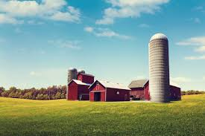
1. What can you see in this picture?

2. In which region of the world is this type of house found?

3. What is the tall cylindrical structure used for?

__________________________________________________

